**Schema design of Inventory Management System**

1. create database inventory_db;
2. use inventory_db;
3. create table Products(

ProductID INT AUTO_INCREMENT PRIMARY KEY,

ProductName VARCHAR(100),

UnitPrice DECIMAL(10, 2),

UnitsInStock INT,

CategoryID INT

);

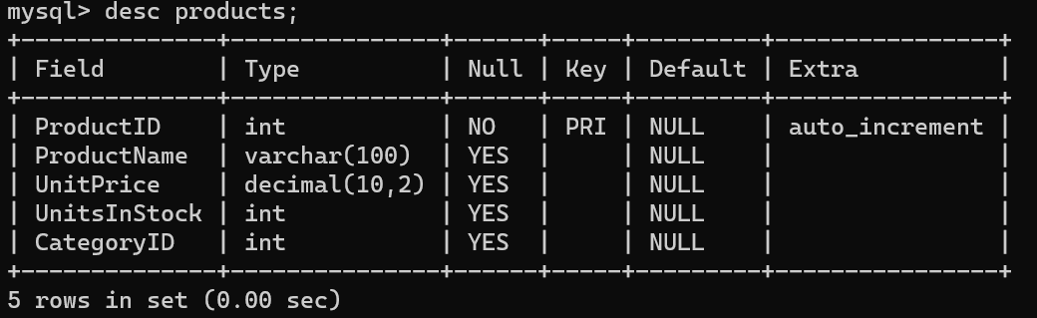

1. create table Orders(

OrderID INT AUTO_INCREMENT PRIMARY KEY,

CustomerID INT,

TotalAmount DECIMAL(10, 2) DEFAULT 0.00,

Status VARCHAR(50)

);

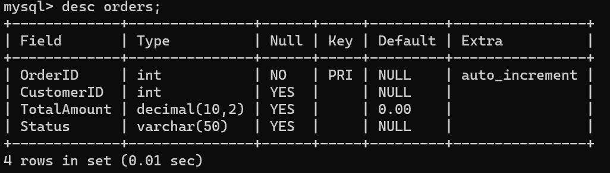

1. create table OrderItems(

OrderItemID INT AUTO_INCREMENT PRIMARY KEY,

OrderID INT,

ProductID INT,

Quantity INT,

FOREIGN KEY (OrderID) REFERENCES Orders(OrderID),

FOREIGN KEY (ProductID) REFERENCES Products(ProductID)

);

